**Movie Review**

**Horror**

1. The Purge: Anarchy (2014)

*The Purge: Anarchy is an American dystopian action horror film written and directed by James DeMonaco. One night per year, the government sanctions a 12-hour period in which citizens can commit any crime they wish without fear of punishment.*

*I think the act of purging is unethical. Based on the three movies of The Purge, everyone is so focused on killing one another even though they are permitted to commit any crime such as stealing, forgery, vandalism, etc. There are better ways to release your anger than having an annual purge.*

1. Split (2016)

*Split is an American psychological horror film written, co-produced, and directed by M. Night Shyamalan. Kevin has evidenced 23 personalities to his psychiatrist Dr. Fletcher but there remains one still submerged who is set to materialize and dominate all of the others.*

*I think this movie reveals a great raw exhibit of someone with DID (Dissociative Identity Disorder). It serves as an awareness to people who have no understanding of this mental illness.*

**Romance**

1. The Notebook (2004)

*The Notebook cuts between the same couple at two seasons in their lives. We see them in the urgency of young romance, and then we see them as old people, she disappearing into the shadows of Alzheimer's, he steadfast in his love. It is his custom every day to read to her from a notebook that tells the story of how they met and fell in love and faced obstacles to their happiness. Sometimes, he says, if only for a few minutes, the clouds part and she is able to remember who he is and who the story is about.*

1. A Walk in the Clouds (1995)

*A Walk in the Clouds is a glorious romantic fantasy, aflame with passion and bittersweet longing. One needs perhaps to have a little of these qualities in one's soul to respond fully to the film, which to a jaundiced eye might look like overworked melodrama, but that to me sang with innocence and trust.*

**Comedy**

1. White Chicks (2004)

*White Chicks is a 2004 American comedy film directed by Keenen Ivory Wayans, who wrote and produced alongside his brothers Shawn and Marlon Wayans. Distributed by Revolution Studios and Columbia Pictures, Shawn and Marlon Wayans portray two African American male FBI agents who disguise themselves as two white women.*

1. Deadpool 2 (2018)

*Deadpool 2 is a 2018 American superhero film based on the Marvel Comics character Deadpool, distributed by 20th Century Fox. It is the eleventh installment in the X-Men film series, and a direct sequel to the 2016 film Deadpool. The film is directed by David Leitch from a script by Rhett Reese, Paul Wernick, and Ryan Reynolds, with Reynolds starring in the title role alongside Josh Brolin, Morena Baccarin, Julian Dennison, Zazie Beetz, T.J. Miller, Brianna Hildebrand, and Jack Kesy. In the film, Deadpool forms the team X-Force to protect a young mutant from the time-traveling soldier Cable.*

**Fantasy**

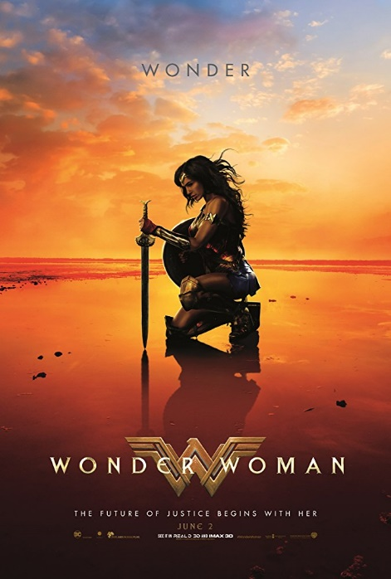

1. Wonderwoman (2017)

*Before she was Wonder Woman (Gal Gadot), she was Diana, princess of the Amazons, trained to be an unconquerable warrior. Raised on a sheltered island paradise, Diana meets an American pilot (Chris Pine) who tells her about the massive conflict that's raging in the outside world. Convinced that she can stop the threat, Diana leaves her home for the first time. Fighting alongside men in a war to end all wars, she finally discovers her full powers and true destiny.*

I think that the movie itself is not just fantasy, action and moreso, it also speaks of what love really is and what sacrifices we all could possibly do just for the people that we truly love.

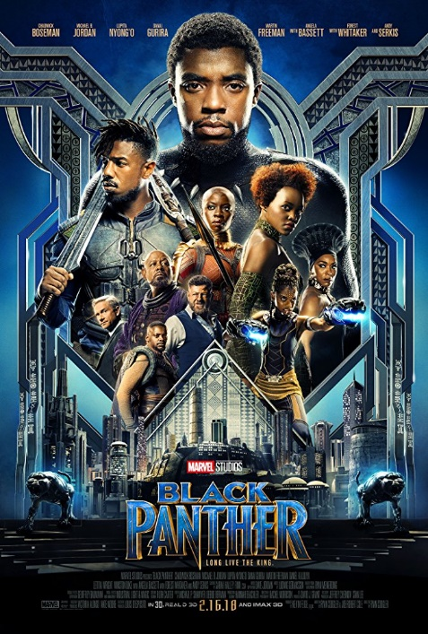

1. Black Panther (2018)

*After the events of Captain America: Civil War, King T'Challa returns home to the reclusive, technologically advanced African nation of Wakanda to serve as his country's new leader. However, T'Challa soon finds that he is challenged for the throne from factions within his own country. When two foes conspire to destroy Wakanda, the hero known as Black Panther must team up with C.I.A. agent Everett K. Ross and members of the Dora Milaje, Wakandan special forces, to prevent Wakanda from being dragged into a world*

I think that the movie itself is an eye opene to what and where good leadership may bring us. Despite of our pasts and of the faults we’ve done, there are still moments in the future that we may able to correct.

**Action**

1. Movie 1

* *// movie review*

1. Movie 2

* *// movie review*

Task 1: Movie Review of at least 2 movies.

Task 2: Pictures of the Movies